LAB ASSIGNMENT 2

DESIGN AND ANALYSIS OF ALGORITHMS LAB
(Course Code: ENCA351)
Algorithm Performance Measurement and Benchmarking Tool
NAME : Tamanna Deshwal
Roll No. : 2401201138
Course : BCA (AI & DS)
SEMESTER : V
SESSION : "A"
SUBMITTED TO : Dr. Aarti

1. Aim of the Lab
To develop an Algorithm Performance Measurement and Benchmarking Tool in Python that executes algorithms and code snippets for different input sizes, measures their execution time, memory usage and number of operations, compares theoretical and experimental complexity, and shows the results as tables and graphs.

Objectives
- Understand practical techniques for algorithm performance analysis.
- Measure execution time and memory consumption of programs.
- Compare theoretical complexity with experimental results.
- Analyse the effect of input size on algorithm behaviour.
- Develop an interactive benchmarking application using Streamlit.

2. Introduction

2.1 Importance of algorithm analysis
Algorithm analysis tells us how the running time and memory needed by a program grow when the input becomes larger. An algorithm that works quickly on 100 items may become very slow on 1,00,000 items. By studying notations such as O(1), O(log n), O(n) and O(n²), a programmer can choose the right algorithm before using it in a real application.

2.2 Need for performance measurement
Theory only gives the growth trend, not the real numbers. By actually running the code and measuring execution time and memory, we can check whether the practical behaviour matches the theory and we can discover hidden costs such as the call stack in recursion or the cost of big-number multiplication in factorial programs.

2.3 What this project does
The project has one reusable BenchmarkEngine that measures any function. It is used on six programs: Linear Search, Binary Search, Single Loop Traversal, Nested Loop Traversal, Recursive Factorial and Iterative Factorial. A Streamlit web application (app.py) and a Jupyter notebook (project_notebook.ipynb) present the results.

3. Project Setup and Tools

3.1 Environment setup
The project was set up with a Python virtual environment so that all libraries stay inside the project folder. The following commands were used:
python -m venv venv
venv\Scripts\activate
pip install -r requirements.txt
streamlit run app.py

3.2 Libraries used
Library | Use in the project
streamlit | Creates the interactive web application (app.py)
pandas | Stores benchmark results in a DataFrame / CSV file
matplotlib | Draws the comparison graphs
numpy | Calculates the growth exponent (log-log slope)
memory_profiler | Installed as required by the lab (memory is measured with tracemalloc, which is built into Python)
jupyter | Runs project_notebook.ipynb
time, tracemalloc (built-in) | time.perf_counter() measures time, tracemalloc measures peak memory

3.3 Project files
File | Purpose
search_analysis.py | Linear Search, Binary Search and the dataset generator (counts comparisons)
code_benchmark.py | Single loop, nested loop, recursive factorial, iterative factorial (count operations)
benchmark_engine.py | BenchmarkEngine class: measures time, memory and operations; runs all benchmarks
visualization.py | Draws the graphs and builds the theoretical vs observed complexity table
app.py | Streamlit web application with 4 tabs
project_notebook.ipynb | The complete project executed step by step in Jupyter
README.md, requirements.txt, .gitignore | Documentation, library list and git ignore rules

3.4 How the measurement works
- Execution time: time.perf_counter() is called before and after the function. The run is repeated 5 times and the average is taken, because very small times change a little from run to run.
- Memory usage: tracemalloc.start() begins tracking and tracemalloc.get_traced_memory() returns the peak memory (in KB) used during one run. Memory is measured in a separate run because tracemalloc makes the code slower.
- Number of operations: Every function keeps a counter and returns (result, operations). For searches this counter is the number of comparisons. This count does not depend on the computer, so it is the most reliable proof of complexity.
- Worst case for searches: In the automated benchmark the key is not present in the list (-1), so both searches do the maximum work.

4. Theory of the Algorithms Used

4.1 Linear Search
Linear Search checks every element one by one from the start until the target is found or the list ends. It works on unsorted data.

4.2 Binary Search
Binary Search works only on a sorted list. It compares the target with the middle element and throws away half of the list in every step, so the interval keeps halving.

4.3 Single Loop Traversal
One loop visits each of the n elements exactly once, so it does n steps.

4.4 Nested Loop Traversal
A loop inside a loop visits every pair (i, j). The outer loop runs n times and each time the inner loop runs n times, so n × n = n² steps.

4.5 Recursive Factorial
Uses n! = n × (n−1)!. The function calls itself n times, and every call stays on the call stack until the last one returns, so it needs O(n) extra space.

4.6 Iterative Factorial
Uses one loop and one variable (result), multiplying 2, 3, ..., n. It needs only O(1) extra space.

4.7 Theoretical complexity table
Algorithm / Pattern | Best Case | Average Case | Worst Case | Space
Linear Search | O(1) | O(n) | O(n) | O(1)
Binary Search | O(1) | O(log n) | O(log n) | O(1)
Single Loop | O(n) | O(n) | O(n) | O(1)
Nested Loop | O(n²) | O(n²) | O(n²) | O(1)
Factorial (Recursive) | O(n) | O(n) | O(n) | O(n)
Factorial (Iterative) | O(n) | O(n) | O(n) | O(1)

5. Source Code
All the code written for this project is given below with a short explanation of each file.

5.1 search_analysis.py (Linear Search, Binary Search, dataset generator)
- generate_dataset(size, sorted_data): creates a list of unique random numbers. When sorted_data is True the list is sorted, which Binary Search needs.
- linear_search(arr, target): goes through the list from left to right. A counter "comparisons" is increased at every check. It returns (index, comparisons), or (-1, comparisons) when the target is absent.
- binary_search(arr, target): keeps two pointers low and high. In each step it checks the middle element: if equal it stops, if the middle is smaller it moves low up, otherwise it moves high down. The counter records the comparisons.

"""Task 2 - Search algorithms (Linear Search and Binary Search).

Both functions return (index, comparisons) so we can show the
number of comparisons made.
"""
import random

def generate_dataset(size, sorted_data=False):
"""Make a list of `size` unique random numbers."""
data = random.sample(range(size * 10), size)
if sorted_data:
data.sort()
return data

def linear_search(arr, target):
"""Returns (index of target or -1, number of comparisons)."""
comparisons = 0
for i, value in enumerate(arr):
comparisons += 1
if value == target:
return i, comparisons
return -1, comparisons

def binary_search(arr, target):
"""arr MUST be sorted. Returns (index of target or -1, comparisons)."""
comparisons = 0
low, high = 0, len(arr) - 1
while low <= high:
mid = (low + high) // 2
comparisons += 1
if arr[mid] == target:
return mid, comparisons
elif arr[mid] < target:
low = mid + 1
else:
high = mid - 1
return -1, comparisons

if __name__ == "__main__":
data = generate_dataset(10, sorted_data=True)
print("Data:", data)
print("Linear search for", data[3], "->", linear_search(data, data[3]))
print("Binary search for", data[3], "->", binary_search(data, data[3]))

5.2 code_benchmark.py (loops and factorial programs)
- single_loop(n): adds numbers 0 to n−1 with one loop and counts the steps. Time O(n).
- nested_loop(n): two loops, adds 1 for every (i, j) pair, so the operation count is exactly n². Time O(n²).
- factorial_recursive(n): calls itself with n−1 until n ≤ 1. It returns the value and the number of calls. Space O(n) because of the call stack.
- factorial_iterative(n): multiplies result by 2, 3, ..., n in a loop. Space O(1).
- SNIPPETS dictionary: maps the names shown in the app to the functions, so the app can run any selected snippet.

"""Task 3 - Code snippets to benchmark.

Every function returns (result, operations) where `operations`
is a simple count of how many basic steps were done.
"""

def single_loop(n):
"""Sums 0..n-1 using a single loop. O(n)"""
total = 0
operations = 0
for i in range(n):
total += i
operations += 1
return total, operations

def nested_loop(n):
"""Counts all (i, j) pairs using a nested loop. O(n^2)"""
total = 0
operations = 0
for i in range(n):
for j in range(n):
total += 1
operations += 1
return total, operations

def factorial_recursive(n):
"""n! using recursion. O(n) time, O(n) stack space."""
if n <= 1:
return 1, 1
value, ops = factorial_recursive(n - 1)
return n * value, ops + 1

def factorial_iterative(n):
"""n! using a loop. O(n) time, O(1) space."""
result = 1
operations = 0
for i in range(2, n + 1):
result *= i
operations += 1
return result, operations

# Names shown in the app -> function
SNIPPETS = {
"Single Loop Traversal": single_loop,
"Nested Loop Traversal": nested_loop,
"Recursive Factorial": factorial_recursive,
"Iterative Factorial": factorial_iterative,
}

if __name__ == "__main__":
for name, func in SNIPPETS.items():
print(name, "(n=10) ->", func(10))

5.3 benchmark_engine.py (Automated Benchmarking Engine)
- measure(func, args, repeats): runs the function once under tracemalloc to get peak memory, then runs it several times with time.perf_counter() to get the average time. It also reads the operation count returned by the function.
- run(func, input_sizes, name, arg_builder): repeats measure() for every input size and stores one result row (algorithm, input_size, time_sec, memory_kb, operations). arg_builder creates the input for a given n, for example a list of n numbers.
- as_dataframe(): converts all results into a pandas DataFrame.
- run_all_benchmarks(): runs all six programs with the suggested input sizes and returns the complete table. sys.setrecursionlimit(5000) is used so recursive factorial works for n = 1000.

"""Task 1 + 4 - Reusable benchmarking engine.

Measures execution time (time.perf_counter), peak memory (tracemalloc)
and number of operations for any function and many input sizes.
"""
import sys
import time
import tracemalloc

import pandas as pd

from search_analysis import linear_search, binary_search, generate_dataset
from code_benchmark import single_loop, nested_loop, factorial_recursive, factorial_iterative

# Recursive factorial with n = 1000 needs a deeper stack than the default
sys.setrecursionlimit(5000)

class BenchmarkEngine:
def __init__(self):
self.results = []

def measure(self, func, args, repeats=5):
"""Run func once for memory and `repeats` times for time.
Returns (avg_time_sec, peak_memory_kb, operations)."""
# 1) memory (separate run, because tracemalloc slows code down)
tracemalloc.start()
output = func(*args)
peak = tracemalloc.get_traced_memory()[1]
tracemalloc.stop()

# 2) time (average of several runs)
total = 0
for _ in range(repeats):
start = time.perf_counter()
func(*args)
total += time.perf_counter() - start

# functions return (result, operations)
operations = output[1] if isinstance(output, tuple) else None
return total / repeats, peak / 1024, operations

def run(self, func, input_sizes, name=None, arg_builder=lambda n: (n,), repeats=5):
"""Benchmark func for every n in input_sizes."""
name = name or func.__name__
for n in input_sizes:
t, mem, ops = self.measure(func, arg_builder(n), repeats)
self.results.append({
"algorithm": name,
"input_size": n,
"time_sec": t,
"memory_kb": mem,
"operations": ops,
})
return self

def as_dataframe(self):
return pd.DataFrame(self.results)

# ---- Input sizes used by the automated run (Task 4) ----
SEARCH_SIZES = [100, 1000, 10000, 50000]
FACTORIAL_SIZES = [100, 500, 1000]
LOOP_SIZES = [100, 1000, 10000, 50000]
NESTED_SIZES = [100, 1000, 5000, 10000] # 50,000 would need 2.5 billion steps

def run_all_benchmarks():
"""Runs every algorithm for every input size and returns a DataFrame."""
engine = BenchmarkEngine()

# Worst case for both searches: the key is NOT in the list
engine.run(linear_search, SEARCH_SIZES, name="Linear Search",
arg_builder=lambda n: (generate_dataset(n), -1))
engine.run(binary_search, SEARCH_SIZES, name="Binary Search",
arg_builder=lambda n: (generate_dataset(n, sorted_data=True), -1))

engine.run(factorial_recursive, FACTORIAL_SIZES, name="Recursive Factorial")
engine.run(factorial_iterative, FACTORIAL_SIZES, name="Iterative Factorial")

engine.run(single_loop, LOOP_SIZES, name="Single Loop")
engine.run(nested_loop, NESTED_SIZES, name="Nested Loop", repeats=1)
return engine.as_dataframe()

if __name__ == "__main__":
df = run_all_benchmarks()
print(df)
df.to_csv("benchmark_results.csv", index=False)
print("Saved benchmark_results.csv")

5.4 visualization.py (graphs and complexity table)
- compare_chart(): draws a line graph of input size against time (or memory) for the algorithms given.
- make_all_charts(): creates the 3 time graphs and 3 memory graphs and saves them as PNG files.
- growth_exponent(): finds the slope of log(time) against log(n) using numpy. A slope near 1 means linear growth, near 2 means quadratic growth and near 0 means almost constant.
- complexity_table(): builds the table that places theoretical complexity next to the observed time, memory, growth exponent and trend.

"""Task 5 + 6 - Charts and complexity table."""
import numpy as np
import pandas as pd
import matplotlib
matplotlib.use("Agg") # lets us save charts without opening a window
import matplotlib.pyplot as plt

# Theoretical complexity (Task 6)
THEORY = {
"Linear Search": ("O(n)", "O(1)"),
"Binary Search": ("O(log n)", "O(1)"),
"Recursive Factorial": ("O(n)", "O(n)"),
"Iterative Factorial": ("O(n)", "O(1)"),
"Single Loop": ("O(n)", "O(1)"),
"Nested Loop": ("O(n²)", "O(1)"),
}

def compare_chart(df, algos, x_label, title, column="time_sec", y_label="Execution Time (seconds)", filename=None):
"""Line chart comparing the given algorithms on one graph."""
fig, ax = plt.subplots(figsize=(8, 5))
for algo in algos:
part = df[df["algorithm"] == algo]
if len(part) > 0:
ax.plot(part["input_size"], part[column], marker="o", label=algo)
ax.set_xlabel(x_label)
ax.set_ylabel(y_label)
ax.set_title(title)
ax.legend()
ax.grid(True)
if filename:
fig.savefig(filename, dpi=150, bbox_inches="tight")
return fig

def make_all_charts(df, folder="."):
"""Creates the 3 time charts + 3 memory charts. Returns list of file names."""
groups = [
("search", ["Linear Search", "Binary Search"], "Dataset Size", "Linear Search vs Binary Search"),
("factorial", ["Recursive Factorial", "Iterative Factorial"], "Input Size (n)", "Recursive vs Iterative Factorial"),
("loops", ["Single Loop", "Nested Loop"], "Number of Iterations (n)", "Single Loop vs Nested Loop"),
]
files = []
for key, algos, xlabel, title in groups:
f1 = f"{folder}/graph_{key}_time.png"
compare_chart(df, algos, xlabel, title + " - Time", filename=f1)
f2 = f"{folder}/graph_{key}_memory.png"
compare_chart(df, algos, xlabel, title + " - Memory", "memory_kb", "Peak Memory (KB)", f2)
files += [f1, f2]
plt.close("all")
return files

def growth_exponent(sizes, times):
"""Slope of log(time) vs log(n). ~1 = linear, ~2 = quadratic, ~0 = very flat."""
slope = np.polyfit(np.log(sizes), np.log(times), 1)[0]
return slope

def trend_name(exponent):
if exponent < 0.4:
return "Almost constant / logarithmic"
if exponent < 1.6:
return "Linear growth"
return "Quadratic growth"

def complexity_table(df):
"""Theoretical vs observed table (Task 6)."""
rows = []
for algo, (time_c, space_c) in THEORY.items():
part = df[df["algorithm"] == algo]
if len(part) < 2:
continue
exp = growth_exponent(part["input_size"], part["time_sec"])
biggest = part.iloc[-1]
rows.append({
"Algorithm": algo,
"Time Complexity": time_c,
"Space Complexity": space_c,
"Largest n": int(biggest["input_size"]),
"Time at largest n (s)": round(biggest["time_sec"], 6),
"Memory at largest n (KB)": round(biggest["memory_kb"], 2),
"Growth exponent": round(exp, 2),
"Observed trend": trend_name(exp),
})
return pd.DataFrame(rows)

if __name__ == "__main__":
df = pd.read_csv("benchmark_results.csv")
print(make_all_charts(df))
print(complexity_table(df).to_string(index=False))

5.5 app.py (Streamlit application)
The application has four tabs: (1) Search Analysis, (2) Code Benchmark, (3) Automated Benchmark with graphs, and (4) Complexity Analysis. It imports the other four files and displays their results as tables and charts.
"""Streamlit app - Algorithm Performance Measurement and Benchmarking Tool.
Run with: streamlit run app.py
"""
import random

import pandas as pd
import streamlit as st

from benchmark_engine import BenchmarkEngine, run_all_benchmarks
from search_analysis import linear_search, binary_search, generate_dataset
from code_benchmark import SNIPPETS
from visualization import compare_chart, complexity_table

st.set_page_config(page_title="Algorithm Performance Tool", layout="wide")
st.title("Algorithm Performance Measurement and Benchmarking Tool")

tab1, tab2, tab3, tab4 = st.tabs([
"1. Search Analysis", "2. Code Benchmark", "3. Automated Benchmark", "4. Complexity Analysis"])

# ------------------------------------------------------------------
# Tab 1 - Search algorithms (Task 2)
# ------------------------------------------------------------------
with tab1:
st.header("Search Algorithm Analysis")
size = st.number_input("Dataset size", 10, 200000, 10000, step=1000)
key_choice = st.radio("Search key", ["Random element from the data", "Key not in data", "Enter my own"])
own_key = st.number_input("Your key", value=0, step=1)

if st.button("Run Search"):
data = generate_dataset(size, sorted_data=True) # sorted so both searches work
if key_choice == "Random element from the data":
key = random.choice(data)
elif key_choice == "Key not in data":
key = -1
else:
key = int(own_key)
st.write(f"Searching for **{key}** in {size} elements")

engine = BenchmarkEngine()
rows = []
for name, func in [("Linear Search", linear_search), ("Binary Search", binary_search)]:
t, mem, comps = engine.measure(func, (data, key))
index = func(data, key)[0]
rows.append({
"Algorithm": name,
"Result": f"Found at index {index}" if index != -1 else "Not found",
"Comparisons": comps,
"Time (s)": f"{t:.8f}",
"Memory (KB)": round(mem, 3),
})
st.table(pd.DataFrame(rows))

# ------------------------------------------------------------------
# Tab 2 - Code snippets (Task 3)
# ------------------------------------------------------------------
with tab2:
st.header("Code Benchmarking")
chosen = st.multiselect("Select code snippets", list(SNIPPETS.keys()), default=list(SNIPPETS.keys()))
n = st.number_input("Input size n", 1, 5000, 500, step=100,
help="Kept below 5000 because nested loop is O(n²) and recursion has a depth limit")

if st.button("Run Snippets"):
engine = BenchmarkEngine()
rows = []
for name in chosen:
t, mem, ops = engine.measure(SNIPPETS[name], (n,))
rows.append({"Snippet": name, "Time (s)": f"{t:.8f}", "Memory (KB)": round(mem, 3), "Operations": ops})
st.subheader("Comparison table")
st.table(pd.DataFrame(rows))

# ------------------------------------------------------------------
# Tab 3 - Automated benchmark + charts (Task 4 + 5)
# ------------------------------------------------------------------
with tab3:
st.header("Automated Benchmarking")
st.info("Runs every algorithm on all suggested input sizes. The nested loop with n = 10,000 takes a few seconds.")
if st.button("Run Full Benchmark"):
with st.spinner("Benchmarking... please wait"):
st.session_state["df"] = run_all_benchmarks()

if "df" in st.session_state:
df = st.session_state["df"]
st.dataframe(df)
st.download_button("Download CSV", df.to_csv(index=False), "benchmark_results.csv")

col1, col2 = st.columns(2)
with col1:
st.pyplot(compare_chart(df, ["Linear Search", "Binary Search"], "Dataset Size", "Search: Size vs Time"))
st.pyplot(compare_chart(df, ["Recursive Factorial", "Iterative Factorial"], "n", "Factorial: n vs Time"))
st.pyplot(compare_chart(df, ["Single Loop", "Nested Loop"], "Iterations", "Loops: Iterations vs Time"))
with col2:
st.pyplot(compare_chart(df, ["Linear Search", "Binary Search"], "Dataset Size", "Search: Memory",
"memory_kb", "Peak Memory (KB)"))
st.pyplot(compare_chart(df, ["Recursive Factorial", "Iterative Factorial"], "n", "Factorial: Memory",
"memory_kb", "Peak Memory (KB)"))
st.pyplot(compare_chart(df, ["Single Loop", "Nested Loop"], "Iterations", "Loops: Memory",
"memory_kb", "Peak Memory (KB)"))

# ------------------------------------------------------------------
# Tab 4 - Complexity table (Task 6)
# ------------------------------------------------------------------
with tab4:
st.header("Theoretical vs Observed Complexity")
if "df" in st.session_state:
st.table(complexity_table(st.session_state["df"]))
st.caption("Growth exponent = slope of log(time) vs log(n): about 1 means linear, about 2 means quadratic.")
else:
st.warning("Run the full benchmark in tab 3 first.")

6. Output Screenshots and Explanation
The application was run with the command streamlit run app.py. Each screenshot below is explained one by one.

6.1 Search Analysis (Task 2)
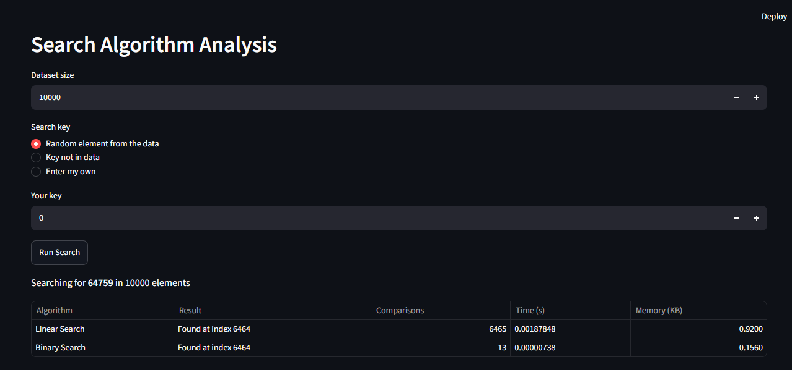
Figure 1: Search Analysis tab - Linear Search vs Binary Search
In this screenshot a list of 10,000 numbers was made and one number (64759) was searched. Both searches found it at index 6464. Linear Search took 6465 comparisons and 0.0019 seconds, but Binary Search took only 13 comparisons and 0.0000074 seconds. So Binary Search is much faster.

6.2 Code Benchmarking (Task 3)
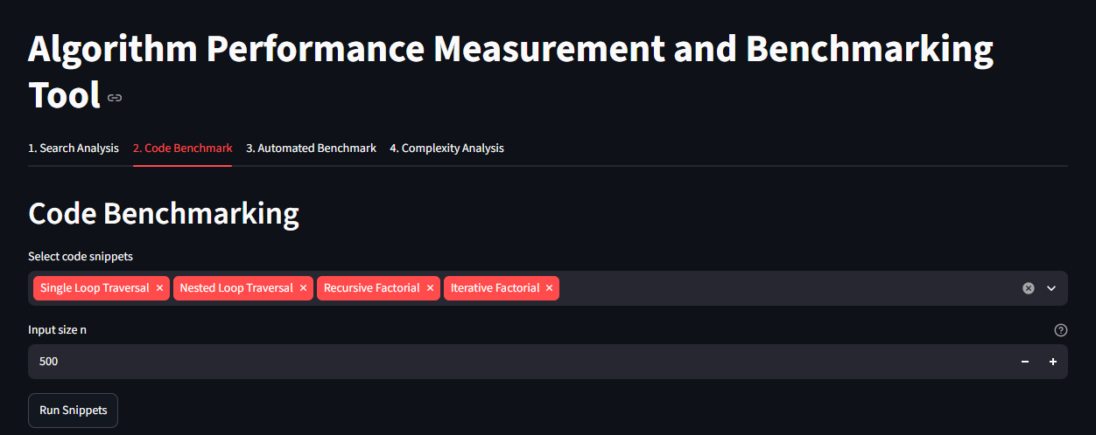
Figure 2: Code Benchmark tab - selecting snippets and input size
Here we choose which code snippets to run and the value of n. All four snippets are selected with n = 500.
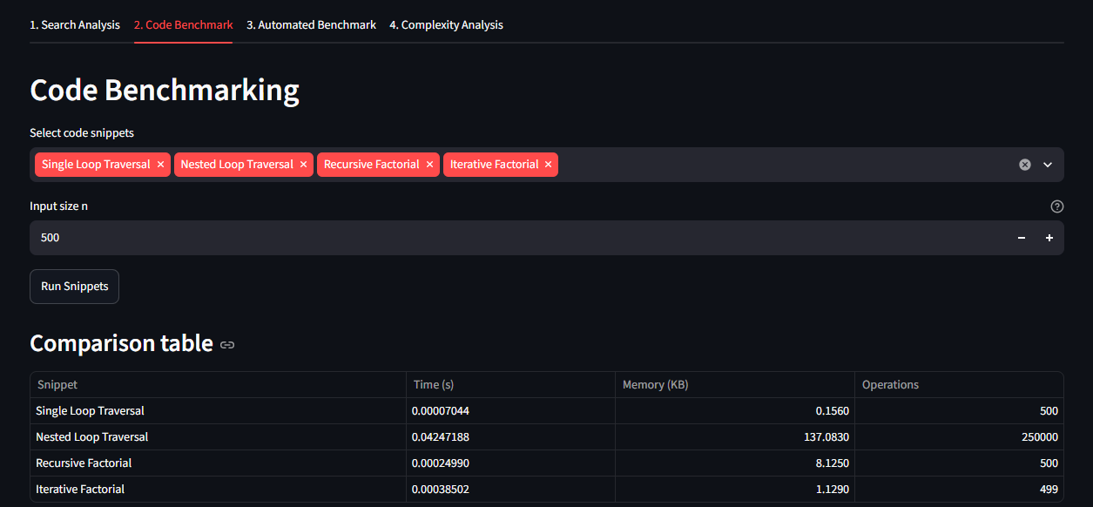
Figure 3: Comparison table of the code snippets for n = 500
The table shows time, memory and operations of each snippet. The nested loop took the most time (250000 operations) while the single loop took very little (500 operations). Recursive factorial used more memory (8.125 KB) than iterative factorial (1.129 KB).

6.3 Automated Benchmark (Task 4)
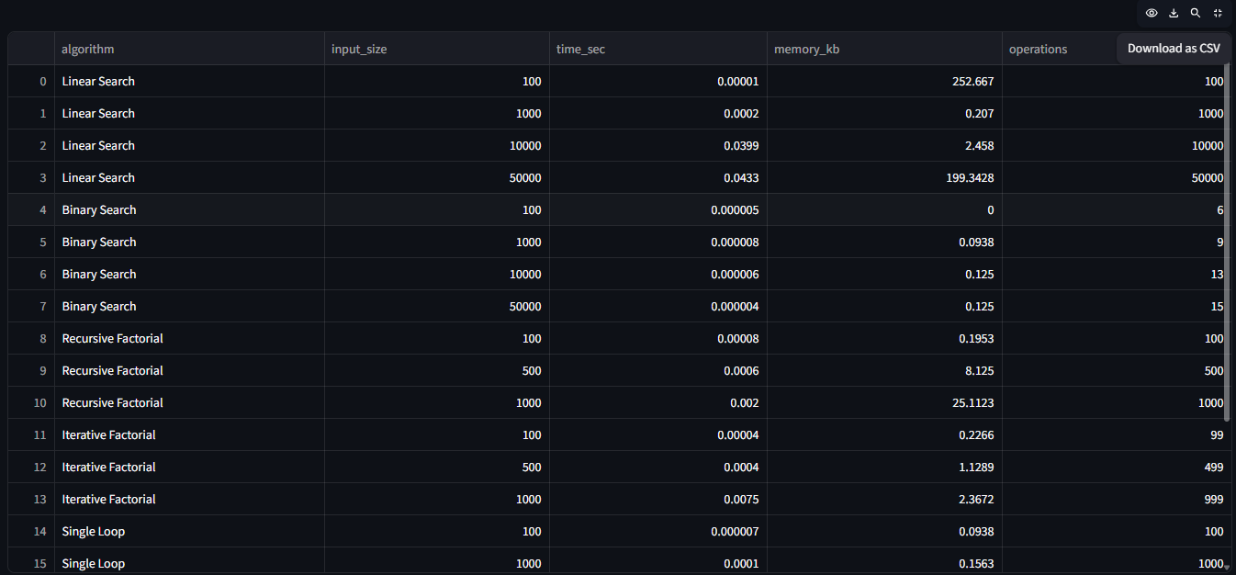
Figure 4: Automated benchmark results table (rows 0 to 15)
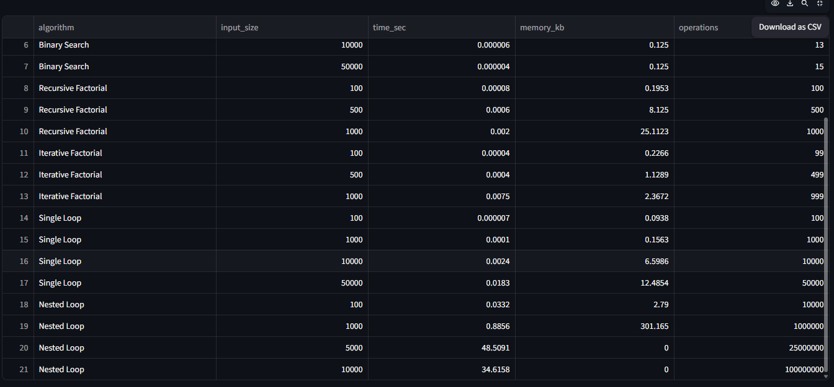
Figure 5: Automated benchmark results table (rows 6 to 21)
This table is the result of the automated benchmark. It runs every program for all input sizes and saves time, memory and operations. Both screenshots show the same table, one at the top and one at the bottom.
The operations column matches the theory: linear search and single loop did n steps, binary search did only 6 to 15 steps, and the nested loop did n x n steps (for example 100000000 for n = 10000).

6.4 Performance graphs (Task 5)
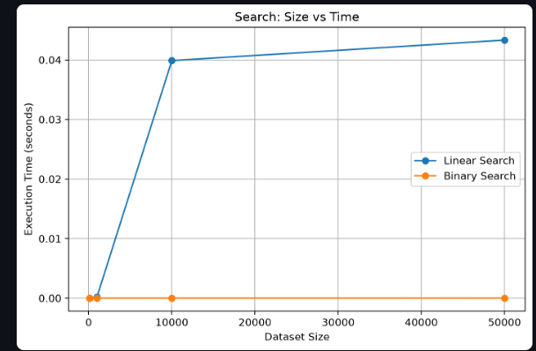
Figure 6: Search - dataset size vs execution time
Linear Search time goes up as the data size increases, but Binary Search stays almost at zero. This means Binary Search is much better for big data.
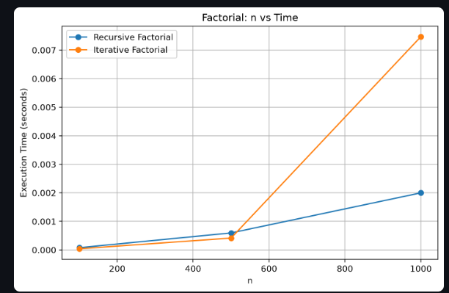
Figure 7: Factorial - input size vs execution time
Time of both factorial programs increases as n increases, which is the O(n) growth. The two lines are close to each other, so there is no big difference in time between them.
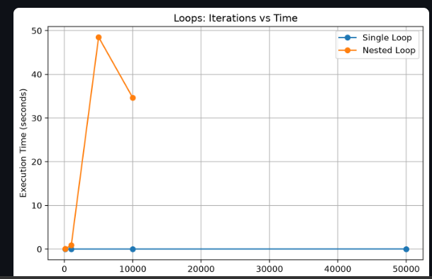
Figure 8: Loops - number of iterations vs execution time
Single Loop stays near zero even for 50,000 iterations, but Nested Loop takes a lot of time. The dip at n = 10000 is only because the computer was busy in the background; the nested loop should keep increasing.
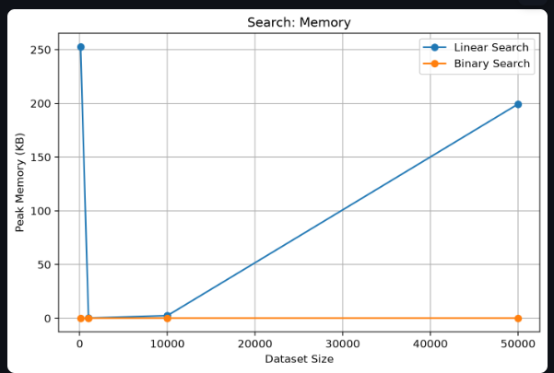
Figure 9: Search - dataset size vs peak memory
Binary Search uses almost no memory. The spikes in Linear Search are not from the algorithm, they come from background memory used by Python while measuring. Both searches need very little memory.
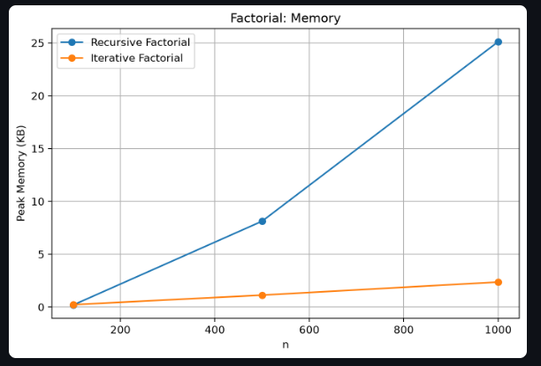
Figure 10: Factorial - input size vs peak memory
Recursive Factorial uses more and more memory as n increases because every function call is stored in the stack. Iterative Factorial uses very little memory. So iterative is better for memory.
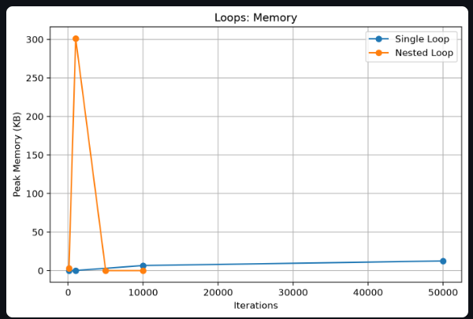
Figure 11: Loops - number of iterations vs peak memory
Memory of both loops is very small. The spike of the Nested Loop is not because of the loop, it is a measuring effect. So loops need very little memory and time is the main issue.

6.5 Complexity analysis output (Task 6)
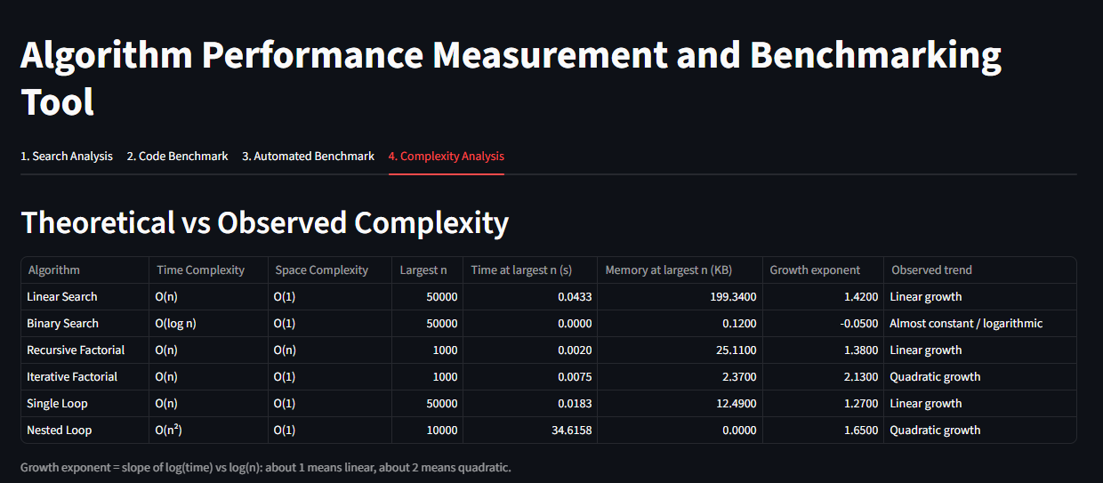
Figure 12: Theoretical vs observed complexity (Complexity Analysis tab)
This table compares theory with the observed results. Binary Search has growth exponent near 0 (almost constant), the linear programs are near 1, and Nested Loop is higher (1.65), moving towards quadratic. The values are not perfect because the computer was busy during the run.

6.6 Reference run from the project notebook
The notebook also saves benchmark_results.csv and complexity_table.csv. These saved results are from another run with less background load and are given here for comparison.
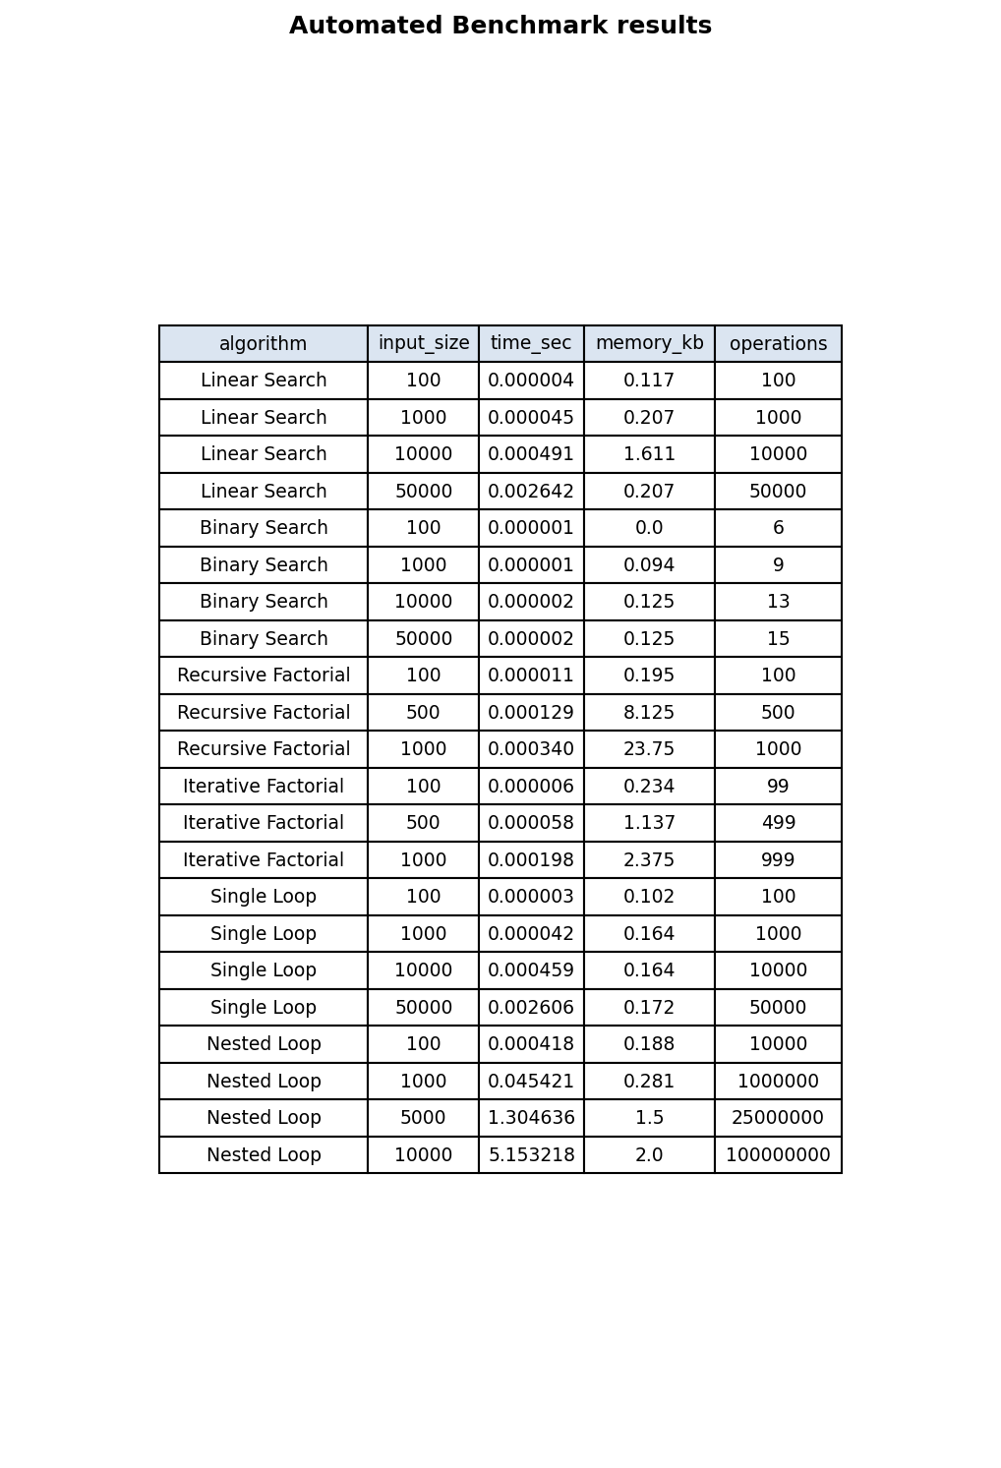
Figure 13: Saved benchmark_results.csv (reference run)
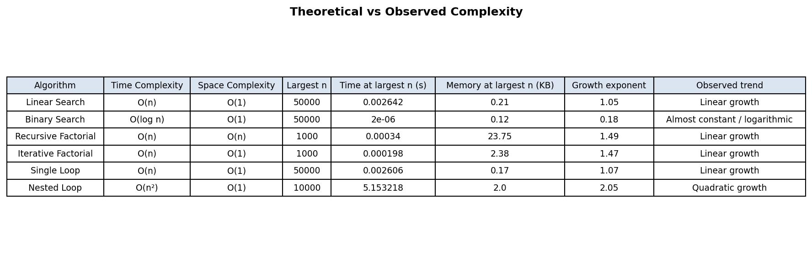
Figure 14: Saved complexity table (reference run)
In this run the growth exponents are close to theory: Linear Search 1.05, Binary Search 0.18, Single Loop 1.07 and Nested Loop 2.05. Factorial is about 1.5 because the numbers become very big in n!. The nested loop for n = 10000 took about 5 seconds here.
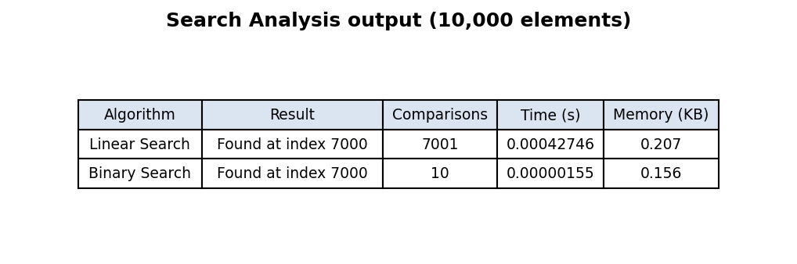
Figure 15: Search output (reference run, 10,000 elements)
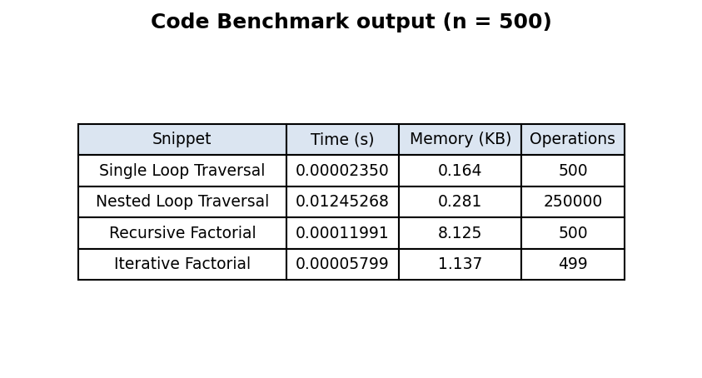
Figure 16: Code snippets output (reference run, n = 500)

7. Complexity Analysis: Theoretical vs Observed
The table combines the theoretical complexity with the operations counted and the growth exponents of the two runs.
Algorithm | Time | Space | Operations counted at largest n | Growth exp. (app run) | Growth exp. (reference run) | Observed trend
Linear Search | O(n) | O(1) | 50000 (n = 50000) | 1.42 | 1.05 | Linear
Binary Search | O(log n) | O(1) | 15 (n = 50000) | -0.05 | 0.18 | Almost constant
Recursive Factorial | O(n) | O(n) | 1000 (n = 1000) | 1.38 | 1.49 | Linear (big numbers)
Iterative Factorial | O(n) | O(1) | 999 (n = 1000) | 2.13 | 1.47 | Linear (big numbers)
Single Loop | O(n) | O(1) | 50000 (n = 50000) | 1.27 | 1.07 | Linear
Nested Loop | O(n²) | O(1) | 100000000 (n = 10000) | 1.65 | 2.05 | Quadratic

The operation counts match the theory exactly: n for the linear programs, about log₂n for Binary Search and n² for the nested loop. The time values follow the same order, with some noise on the computer.

8. Comparative Performance Study

8.1 Linear Search vs Binary Search
At 10,000 elements Linear Search made 6465 comparisons against 13 for Binary Search (Figure 1), and at 50,000 elements the worst case needed 50,000 comparisons against only 15. Binary Search is therefore much better for large sorted data. Its drawback is that the data must be sorted first. For a single search on unsorted data, sorting would cost more than one linear scan, but when many searches are done on the same data, Binary Search is far more efficient. Both use O(1) extra space.

8.2 Recursive Factorial vs Iterative Factorial
Both have O(n) time and perform about n multiplications. The clear difference is space: at n = 1000 the recursive version used about 25 KB and the iterative version about 2.4 KB (Figure 10). Recursion also has a depth limit in Python (we had to raise it to 5000 for n = 1000), while the loop has no such limit. The measured times of the two were very close and the small differences changed between runs, so neither can be called faster on time alone. The iterative method is the safer choice because of its O(1) space.

8.3 Single Loop vs Nested Loop
The Single Loop did 50,000 operations in a few milliseconds, while the Nested Loop did 100 million operations for n = 10000 and needed several seconds (5 s in the reference run). When n increases 10 times, a single loop needs about 10 times more steps, but a nested loop needs 100 times more steps. This shows why O(n²) programs become impractical for large inputs.

8.4 Relationship between complexity and actual time
Complexity predicts how the time grows, not the exact time. The operation counts matched the theory perfectly. The measured times follow the same trend, but small values (microseconds) change from run to run and are affected by the other programs running on the computer. This is why several repetitions are averaged and why operation counts are a useful second measure.

8.5 Time-space trade-offs
Implementation | Time | Space | Comment
Recursive Factorial | O(n) | O(n) | Short and natural code, but uses stack memory and has a recursion limit
Iterative Factorial | O(n) | O(1) | Same time, much less memory, no recursion limit
Binary Search | O(log n) | O(1) | Very fast, but needs the data to be sorted first
Linear Search | O(n) | O(1) | Simple, works on unsorted data, slow for large data

9. Performance Observations and Limitations
- Very small times (microseconds) change between runs, so the average of several runs is used.
- The application run was done while Streamlit, the browser and OneDrive (syncing the venv folder) were working in the background. This explains the higher times for Linear Search and the nested loop, and the unusual point of the nested loop at n = 5000 which is slower than n = 10000.
- The nested loop is run only once because it is slow; a single run is more affected by disturbance than an average of five runs.
- Memory values from tracemalloc for small programs are very small and can show spikes (for example 252 KB for Linear Search at n = 100) because Python allocates memory in the background, especially in the first run.
- The nested loop with n = 50,000 was not run because it needs 2.5 billion steps and would take many minutes in Python; sizes up to 10,000 were used.
- Absolute times depend on the computer, but the growth trends and the operation counts stay the same.

10. Conclusion

10.1 Key findings
- The operation counts matched the theoretical complexity for all six programs: n for the linear programs, about log₂n for Binary Search and n² for the nested loop.
- Binary Search was about 250 times faster than Linear Search at 10,000 elements (13 comparisons against 6465).
- The Nested Loop became very slow (several seconds) even for n = 10,000, while the Single Loop took only milliseconds for 50,000 iterations.
- Recursive Factorial used about 10 times more memory than Iterative Factorial at n = 1000, confirming O(n) against O(1) space.
- Time measurements on a normal computer contain noise, so repeating the runs, counting operations and running the benchmark without other programs give more trustworthy results.

10.2 Most efficient implementations observed
- Searching sorted data: Binary Search.
- Factorial: Iterative Factorial (same time, least memory).
- Traversal: Single Loop; nested loops should be avoided when the problem can be solved with one loop.

10.3 Future enhancements
- Add sorting algorithms (bubble, merge, quick sort) and recursive binary search.
- Allow the user to paste their own code snippet and benchmark it.
- Use memory_profiler for line-by-line memory measurement.
- Repeat the nested loop several times and show the average and standard deviation to reduce noise.
- Use logarithmic graph axes so that very small and very large values can be seen on the same chart.

11. References
- Ellis Horowitz, Sartaj Sahni, Sanguthevar Rajasekaran - Fundamentals of Computer Algorithms.
- Jon Kleinberg and Éva Tardos - Algorithm Design.
- Python Documentation - time and tracemalloc modules.
- Streamlit Documentation.
- memory_profiler Documentation.
- Jupyter Notebook Documentation.

